The Ministry of industry  of Republic of Belarus  Joint stock company  «MINSK AUTOMOBILE PLANT» -  Holding company of «BELAVTOMAZ»  (JSC «MAZ» - Holding company of  «BELAVTOMAZ»)  2, Socialisticheskaya str., 220021, Minsk,  Republic of Belarus  Phone: (+375-17) 217-95-39, 273-76-95  Fax: (+375-17) 217-20-22  e-mail: export@maz.by | Министерство промышленности  Республики Беларусь  Открытое акционерное общество  «Минский автомобильный завод» - управляющая компания холдинга «БЕЛАВТОМАЗ»  (ОАО «МАЗ» - управляющая компания холдинга «БЕЛАВТОМАЗ»)  ул. Социалистическая, 2, 220021, г. Минск,  Республика Беларусь,  Тел.: (+375-17) 217-95-39, 273-76-95  Факс: (+375-17) 217-20-22  www.maz.by

23.08.2013 г. № 142-14/_____

Dear Sirs!

First of all let us express our appreciation of your kind assistance in promotion of MAZ products in the south-east Asia region.
Based on to the instruction of Belarusian Government, JSC “MAZ” – managing company of “BELAVTOMAZ” holding is glad to present commercial offer for MAZ vehicles for Indonesia market, including its price on FCA delivery terms and brief technical characteristics of each model.
Model | Technical characteristics | Price per unit,  US dollars (FCA, Minsk)
Dump-truck with right hand steering-wheel  MAZ-656087-321-700  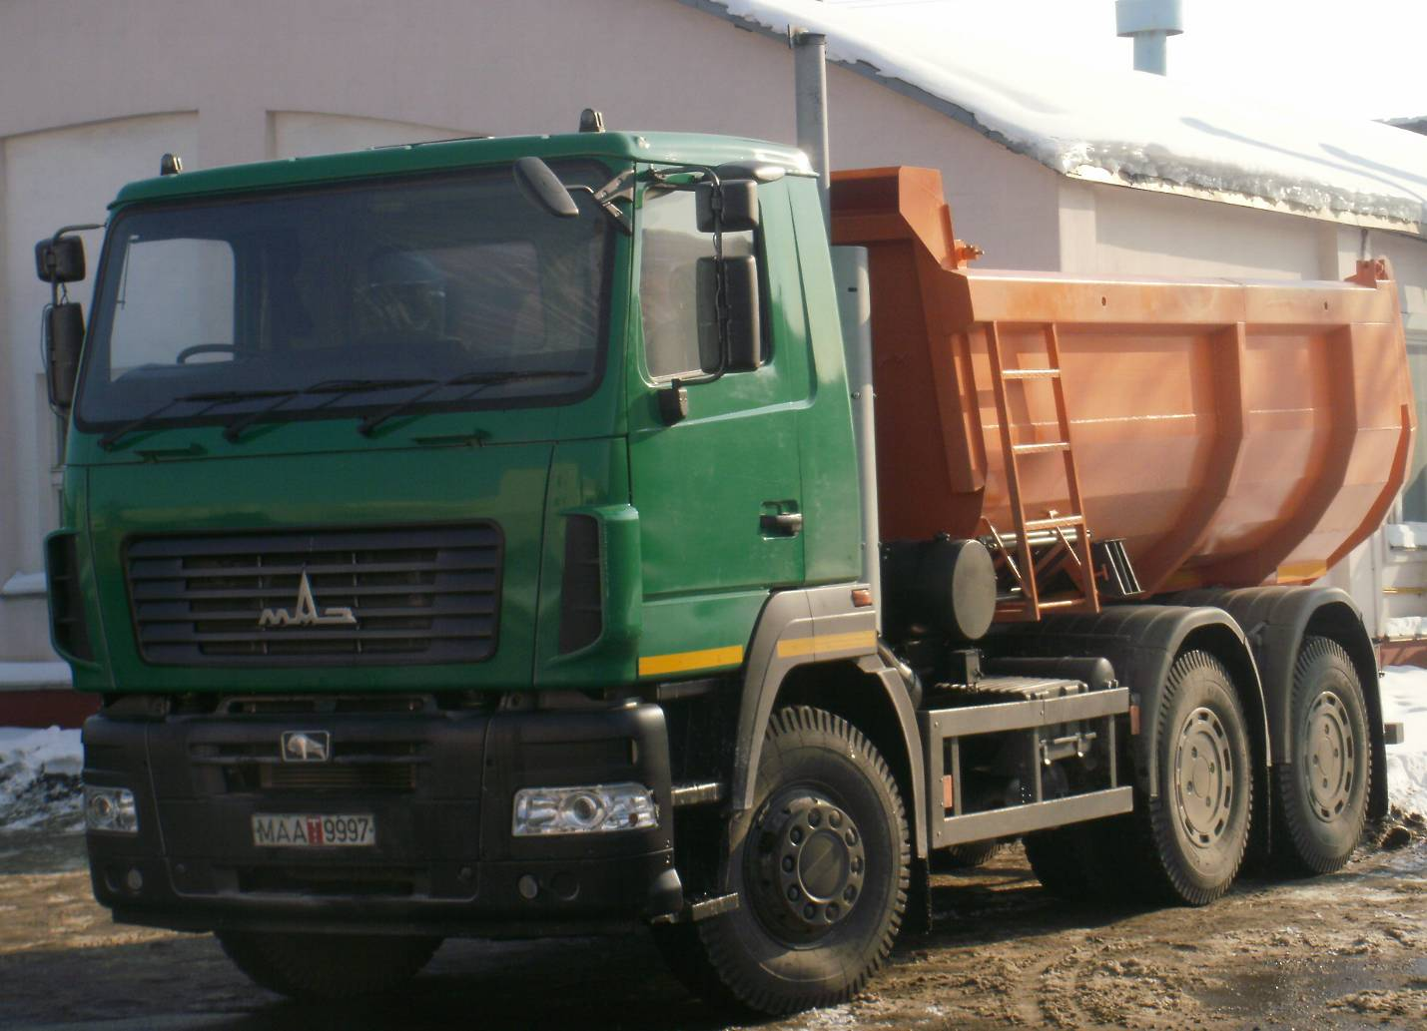 | Engine - Cummins ISLe 375 30 (375 h.p.) Euro-3; gearbox - ZF 16S1820T0 (16 transfers); ABS; fuel tank – 300 l; tires - 12.00R20; payload capacity – 20750 kg; platform volume – 15,4 m³; back load; small cabin. Set of parts and accessories. | 70 540
Chassis with right hand steering-wheel  MAZ-536084-341-713  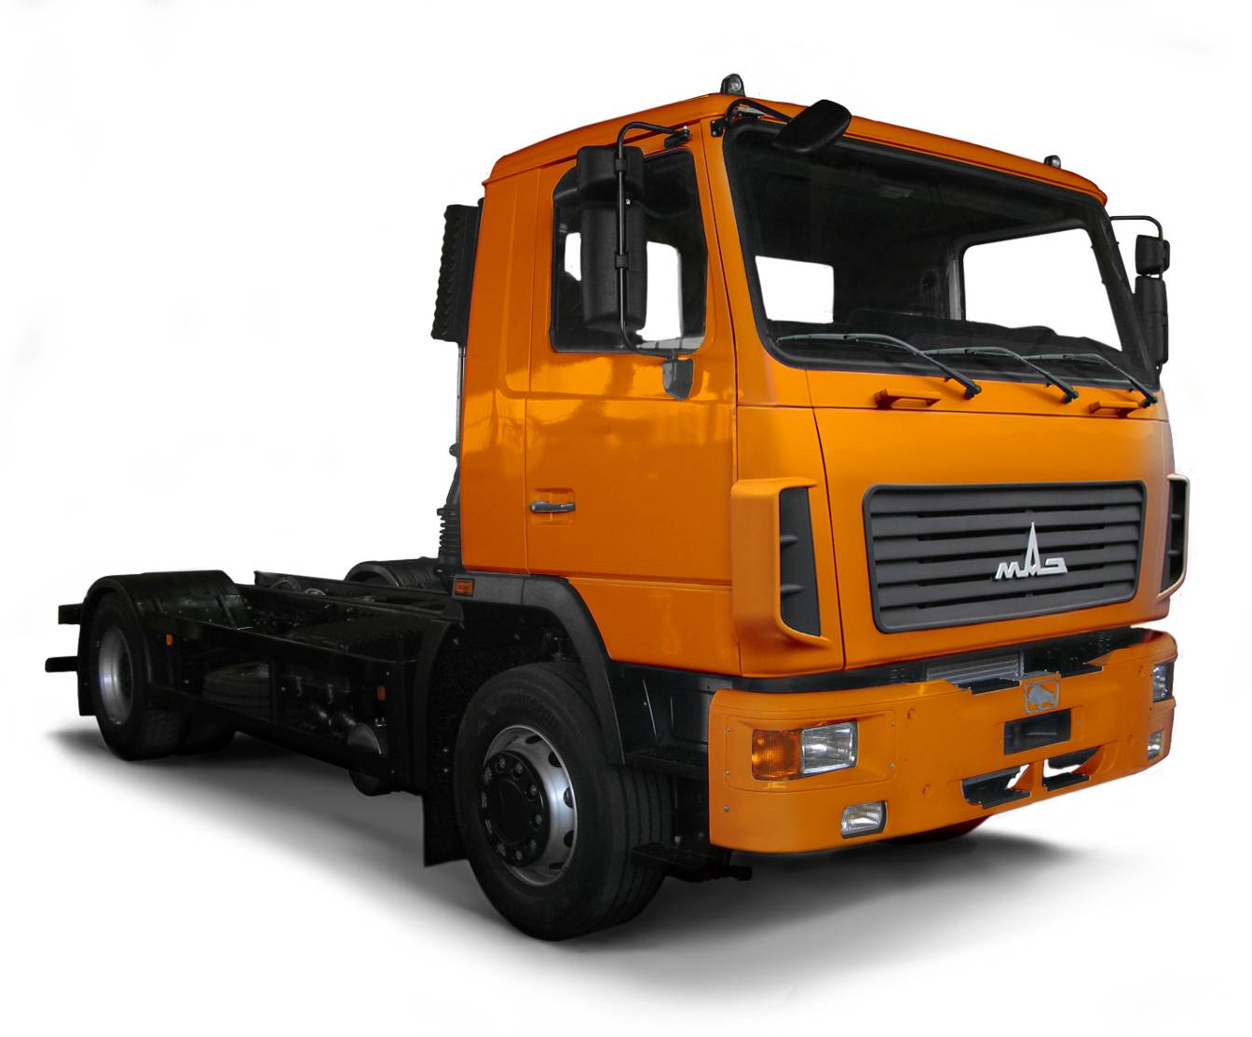 | Engine - Cummins 6ISBe 285 (285 h.p.) Euro -3; gearbox – 9S1310T0 (9 transfers); ABS; fuel tank – 500 l; tyres - 12.00R20; payload capacity – 13 000 kg; small cabin. Set of parts and accessories. | 50 710
Fifth-wheel tractor with right hand steering-wheel  MAZ-646087-1320-712  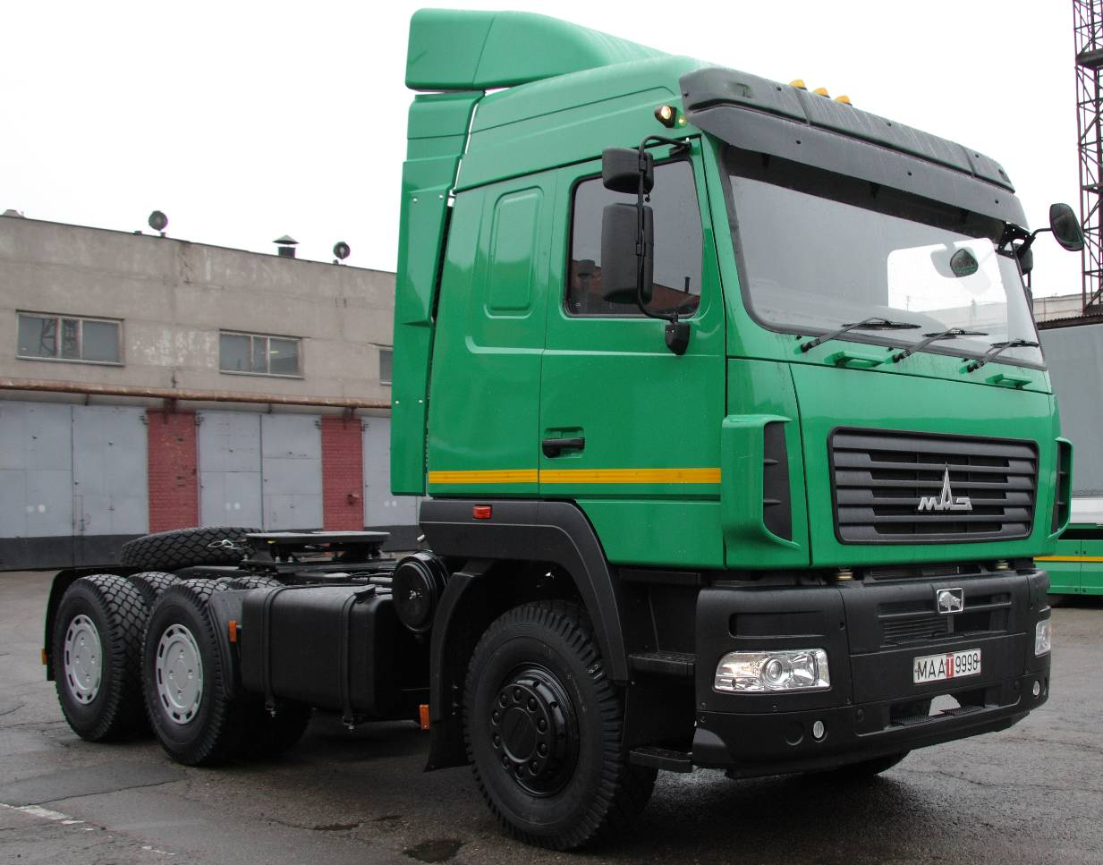 | Engine - Cummins ISLe 375 30 (375 h.p.) Euro-3; gearbox - ZF 16S1820T0 (16 transfers); ABS; fuel tank – 500 l; tires - 12.00R20; fifth-wheel height – 1380 mm; mass come on fifth-wheel assembly – 23100 kg; big cabin. Set of parts and accessories. | 66 230
Semi-trailer  MAZ-953000-014  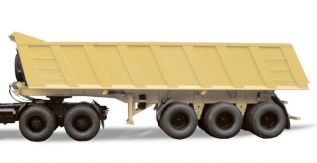 | Payload capacity/fifth wheel payload – 35000kg/17000kg; ABS; dump-truck platform; platform volume – 25m3; tyres - 12.00R20; height by tractor fifth wheel – 1360 mm. Set of parts and accessories. | 31 980
Semi-trailer  MAZ-938662-2010  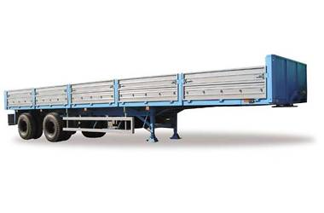 | Payload capacity/fifth wheel payload – 23900kg/11000kg; ABS; platform with steel ramps; platform space – 33m2; tyres - 11.00R20; height by tractor fifth wheel – 1320 mm. Set of parts and accessories. | 20 200

All prices are in dollars USA on FCA Minsk terms (Incoterms 2010).
Payment terms: 100% advance payment or 100% irrevocable latter of credit confirmed by the bank with high stable rating.
VAT rate – 0 % (zero percent).
Production period – depends on quantity of required vehicles.
Price validity – September 30, 2013.

For more information about JSC “Minsk automobile plant” and a range of products, produced by our company, please, visit our web-site www.maz.by, and feel free to contact us by phone numbers below or our e-mail: export@maz.by.
We hope for you further collaboration with us.

Yours faithfully,
Deputy General Director for Foreign
Economic Affairs Goncharik V.A.

Contact person:
Anton Kozlovskiy
Tel./Fax: (+375 17) 217-95-39
Tel.: (+375 17) 273-76-95

