**Investment**

**passport**

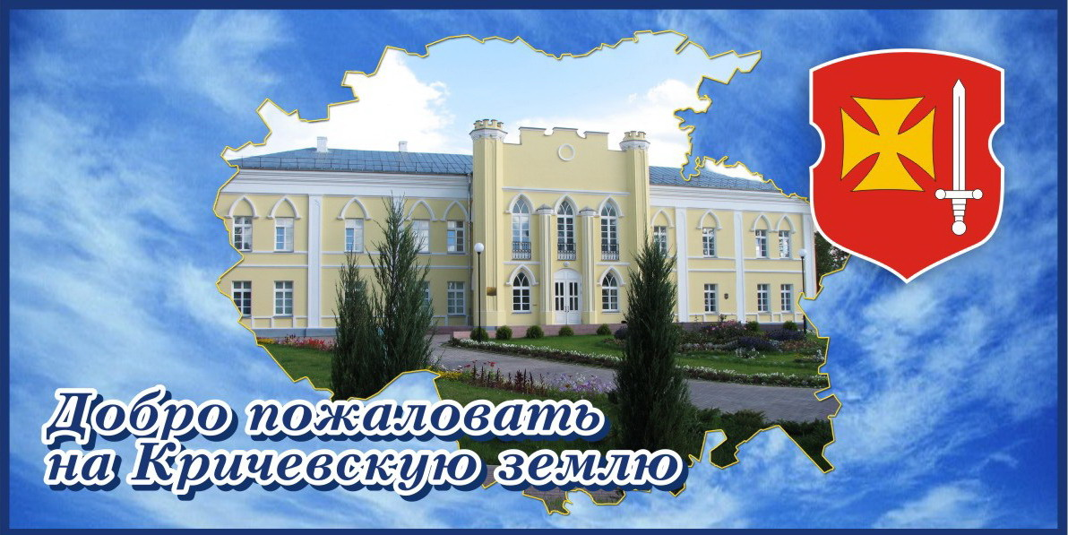

**Dear ladies and gentlemen!**

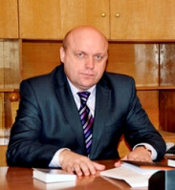Krichev Regional Executive Committee considers it an honour to invite you to Krichev district for realization of your investment projects!

Unique comfortable conditions for business development are created in our district – tax privileges are given, measures of stimulating character in sphere of pricing, payment, bulk purchase of raw and completing sets are established, investment platforms for the organization of any kind of business are formed.

Availability of large producers of cement, items from rubber and PVC, sources of high-quality drinkable water, the large railway junction, the developed system of engineering communications, and also a favourable geographical position along line Р 43 with journey of an order of 100 lorries per hour as well and at a distance of 470 km from Moscow, are competitive advantages for the organization in Krichev district of the new enterprises in sphere of production of building materials and designs, rubber-technical and PVC goods, bottling of drinkable water, building of roadside service objects, rest bases, hotel complexes, generation of alternative kinds of energy and waste recycling, rendering of transport and logistics services.

We will sincerely greet and render all sorts of assistance in realization of your constructive enterprise initiative in our district.

Yours sincerely

The chairman of the Regional

Executive Committee

Vasily Vasilevich Sysoyev

***1.* *[Reference and information material](http://www.multitran.ru/c/m.exe?t=4538930_1_2) about Krichev district***

***History***

Ancient history of Krichev land goes back to the Stone Age (approximately 10 000 years ago). The first human settlements on Krichev lands appeared between 5000-4000 BC, where the river Chornaya Natopa falls into the river Sozh. The primary activities of the population were hunting, fishing and gathering.

In ancient manuscripts Krichev was first mentioned as Krechut in 1136 in the Foundation Charter of Smolensk Prince Rostislav Mstislavovich. At that time (12th century) a new reinforced central part was built in Krichev – a hillfort called Zamkovaya Gora. The fortress was built on a high bank of the river Sozh. A [trading quarter](http://www.multitran.ru/c/m.exe?t=3420356_1_2) Zabelyshenskiy began to form simultaneously with the growth of the fortress on Spasskaya Gora. The trading quarter was populated with merchants and craftsmen who were engaged in metal- and woodworking and potter trade.

[In the 1st half of the 14th century Krichev was annexed to the Mstislavl Principality, and later in 1359 became a part of Grand Duchy of Lithuania](http://www.multitran.ru/c/m.exe?t=4100438_1_2). From the end of the 15th century Krichev became the centre of Krichev volast. Krichev was considered one of the most important borderline castles.

On 23rd August 1633 Krichev was granted Magdeburg rights and the emblem of its own. The town had a system of self-government adopted in accordance with Magdeburg law.

In January 1776 Catherine II presented the Krichev eldership (14274 people) to count G.A.Potyomkin. Krichev land became the principal base for provision of a new built Black Sea Fleet. Krichev shipbuilding yard, built up in 1785, was one of the major Russian shipbuilding centers. In the time of Potyomkin a branch of the Kherson Admiralty with rope and sail manufactories were built in Krichev. There were two leather tanneries, two glass manufacturing plants, a brick factory, a distilling, a copper foundry, iron ore from local marshes was extracted and processed in Krichev. A palace designed in the Russian classical style of architecture upon the project of I.E. Starov was built in Krichev by Potyomkin’s order during 1778-1787.

In 1850-1854 the Moscow-Warsaw road was cut through Krichev volast which played a leading role in the further development of the district.

On 17 July 1924 Krichev district was created.

In the 1930s the construction of industrial enterprises in Krichev land began. The phosphate, chalk, brick plants, a flax mill started working, «Sozhstroi» was founded to ensure the river management. The construction of the cement plant became the most prominent event. In the prewar years electrification, telephone and radio system installation were finished, bus traffic was opened.

In occupation years (1941-1943) all industrial enterprises were ruined.

The town of Krichev was liberated from the Nazi invaders on September 30, 1943. In October 1943 the bread factory was restored. In 1947 the construction of Krichev Rubber Foot-Wear Factory began, and as early as 1949 it turned out its first production. In 1949 the cement plant repair and reconstruction works were finished.

***Geographical characteristics***

Krichev district is situated in the eastern part of Mogilev region. It borders on Klimovichi, Cherikov, Mstislavl districts of Mogilev region and Shumyachi district of Smolensk region. It occupies an area of 77 754 hectares.

At present the population of the district is 33 924 people, 26 610 of them live in town and 7314 people live in the district. The number of employees of industrial enterprises is 2880 people, in the agricultural sector – 1266, in building – 491, in trade and services – 572, in transport and communication organizations – 1171, in financial institutions – 211, in educational institutions – 1556, in health care facilities – 1025, in utility and social service institutions – 532 people.

There are five rural (or village) Soviets: Botvinovka, Kostyushkovichi, Krasnaya Buda, Lobkovichi and Molyatichi which include 103 populated areas.

Krichev land is rich in chalk, sand, sand-gravel mixes. The prevailing soils are as follows: light loam – 68%, sandy clay – 30%. Forests occupy 25,2% of the district area. Bogs occupy 2,9% of the district territory. There is a biologic microreserve, hydrological and hunting reserves of local significance. The total area of farmland is 45 182 hectares, 5844 hectares of which are drained land.

The district is situated within the Orsha-Mogilev Plain. The surface is flat with general inclination from west to east up to the river Sozh valley.

The district is crossed by important railway lines: Unecha-Orsha, Mogilev-Roslavl, and motoroads: Moscow-Brest, Krichev-Mstislavl, Krichev-Belitsa, Krichev-Khodosy.

The distance to Minsk is 370 km, Moscow – 470 km, Kiev – 500 km.

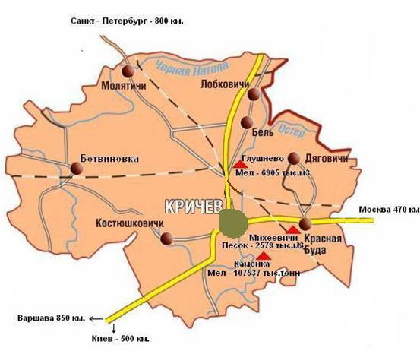

***2. Economic potential***

At present the economic potential of area is presented with industrial and agriculture enterprises, buildings and transport organizations, trading enterprises and consumer services and by entrepreneurs.

**Industry**

The basis of economic potential of the district is made with industrial sector of economy which includes 5 enterprises:

- JSC «Krichevcementnoshifer»;

- RUE «Krichev Rubber Foot-Wear factory»;

- ISS «Krasnobydsky winery», RUE «Klimovichsky liquor-vodka plant»;

- Branch of RUE «Mogilevkhlebprom » Krichev Bread Factory;

- JSC «Krichev freinforced concrete products factory».

JSC «Krichevcementnoshifer»

**The higher organization**: the Ministry of architecture and construction of the Republic of Belarus.

The main kinds of produced goods: cement, asbestos (slate) sheets.

Production capacities: portland cement – 1, 7 million tons a year, asbestos sheets – 110 million agreed piles a year.

**Investment potential:** at present the investment project «construction of a new technological line on manufacture of cement by capacity 1, 8 million tons a year in area of a site «Camenka» is being realized by the enterprise.

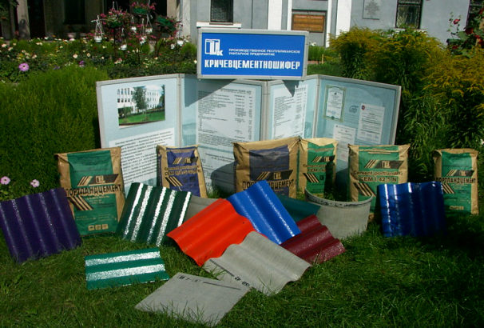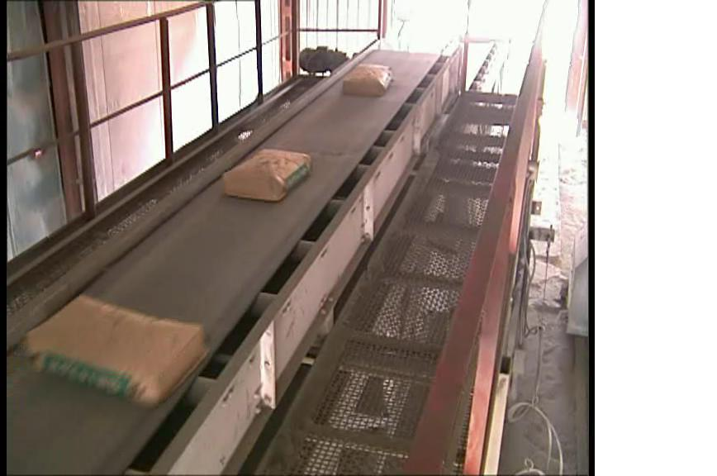

### RUE «Krichev Rubber Foot-Wear factory »

## The higher organization: the Belarusian State Concern Producing Oil and Chemical Goods.

**The main kinds of produced goods:** rubber and polymeric footwear, rubber-technicalgoods.

**Production capacities: t**he production of rubber-technical goods – 500 tons a year. The production of glued footwear (overshoes) – 1,2 million pairs a year. The production of shaped boots – 1,0 million pairs a year. The production of sports footwear – 300 thousand pairs a year. The production of PVC boots – 545 thousand pairs a year. The total production capacity of rubber footwear – 3,0 million pairs.

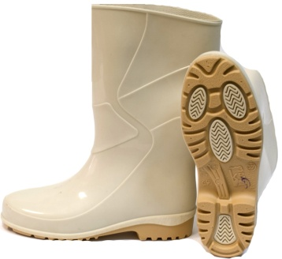 **Investment potential:** at present the factory is carrying out searching for investors to realize projects on development of rubber footwear production and the organization of rubber-technicalgoods production.

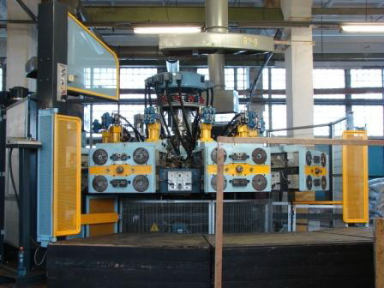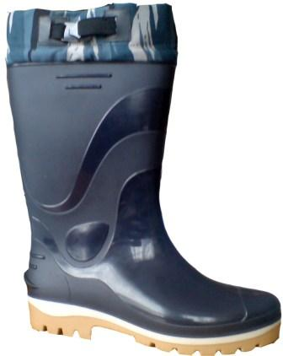

ISS «KRASNOBYDSKY WINERY» RUE «KLIMOVICHSKY LIQUOR-VODCA PLANT»

## The higher organization: RUE «Klimovichsky liquor-vodka plant»

**The main kinds of produced goods:** fruit wines.

**Production capacity:** 200 thousand dkl in a year.

**Investment potential:** at present the project on production and pouring of bread kvass and drinkable water is being worked out.

JSC «KRICHEV FREINFORCED CONCRETE PRODUCTS FACTORY».

## The higher organization: Committee on architecture and constructions Mogilev Regional Executive Committee, OOO KASI. s.r.o.

**The main kinds of produced goods:** modular rein forced concrete designs and goods, wall blocks, marketable concrete.

[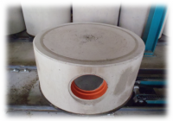](http://zavod-jbi.by/uploads/posts/2012-06/1340872002_klk-10.10.png)[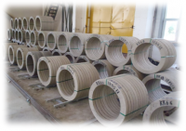](http://zavod-jbi.by/uploads/posts/2012-06/1340872018_ko.png)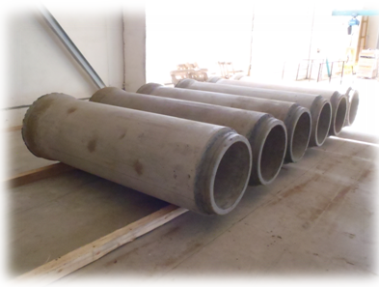

**Investment potential:** at present the investment project with participation of the foreign investor «The organization of production of modular rein forced concrete and panels for construction of blocks of flats with introduction of «know-how» JSC «Krichev freinforced concrete products factory », in Krichev, I, II, III, IV stages» is being realized by the enterprise.

BRANCH OF RUE «MOGILEVKHLEBPROM» KRICHEV BREAD FACTORY

## The higher organization: RUE «Mogilevkhlebprom ».

**The main kinds of produced goods:** bakery and confectionery.

**Investment potential:** at present the investment project on production of cardboard package is being realized at the factory.

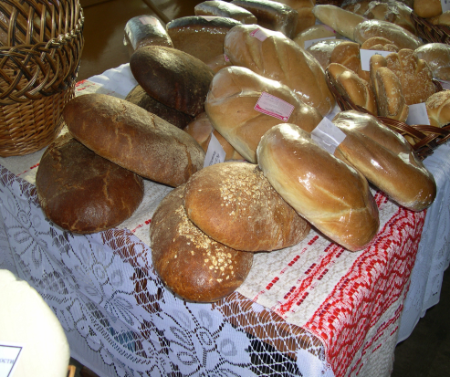 [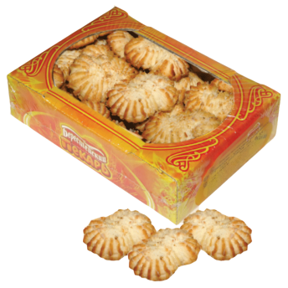](http://bhp.by/konditerskie-izdeliya/Pechene-Margaritki-novoe) [](http://bhp.by/konditerskie-izdeliya/Tort-Ocharovanie)

In our district industrial enterprises of individuals of small business are organized as well: the production of ropes, cords is organized by private enterprise «Belsoyusgrupp», the production of furniture is organized by private enterprise «BudaMebel».

**Agriculture**

Agriculture of Krichev district specializes in milk and meat cattle breeding with developed plant growing. Three agroindustrial complexes, unitary municipal agricultural services and the enterprises serving agriculture: JSC "Krichevraiagropromtehsnab", regional veterinary station, branch of RUSPP on breeding business "Mogilevgosplemfactory " are included into agroindustrial complex of Krichev district.

**Building, transport, mass media**

The building trade of area is represented by 7 building and road-building organizations of state and non- state ownership.

6 transport organizations which carry out cargo and passenger transportation work in the district.

Automobile transportation of passengers in town and the district is carried out by Bus fleet № 3, Krichev subsidiary of JSC «Mogilevoblavtotrans». Bus fleet № 3 organized 9 town, 11 local, 3 long-distance and 1 international routes for service of the population of the town and the district.

The park of vehicles of businessmen numbers 25 cars, which operate at 10 town and 11 local routes.

The regional centre of mail service includes 17 branches of mail service.

The regional newspaper «Krichevskaya zhizn» , and the regional broadcasting inform the population of the town and district about the most significant events occurring in the republic, the district and the region , interactive television ZALA functions in the district.

**Trade, consumer service.**

The trading network of the district is represented by the retail enterprises, a departmental network of the enterprises, regional and district organizations, entities of small and medium business.

250 shops, 53 public catering establishments on 3407 seats, 44 consumer services establishments, 3 markets function on the territory of the district.

**Entities of business.**

As at January 7, 2012 the small business of Krichev district is presented by 130 legal entities and 1004 businessmen. 55 per cent of the legal entities are involved in trade, 13.0 per cent in sphere of services, 7.7 per cent in agriculture, 6.9 per cent in production, 17.4 per cent in other fields of activity.

***3. Social characteristics***

**Education**

The network of educational establishments of the district includes 15 establishments of general secondary education, 11 establishments of preschool education.

State educational establishment «Mogilev Regional Lyceum № 4 (Krichev)» and «Krichev State Professional Agrotechnical College» function in the district.

Establishments of additional education for children and youth «Centre for children and youth creativity «Krechut», «Krichev regional centre of tourism, local lore and excursions for children and youth»,establishments of special education «The Center of the correctional and developing training and rehabilitation », “School of the Olympic Reserve for Children and Youth”. The health-improving complex functions.

«Krichev regional social pedagogical centre» and the orphanage of family type in the village of Kostushkovichi protect the rights of under-aged orphans and children appeared in extreme life situation.

**Culture**

Cultural and educational work is carried out by 43 culture establishments, 16 clubs and Recreation centers among them, the District Centre of culture, 24 libraries, 5 library clubs among them, 2 music schools for children with 10 branches, art school for children with 10 branches, the historical museum. There are 2 departmental club establishments on the territory of Krichev.

On the basis of the district library the district information and ideological centre was created.It has an access to the computer legal data base.

***4. Financial sector***

**Banks**

At present the financial sector of the district is represented by two banks: a branch office 714 of JSC JSSB “Belarusbank’’ and a branch office of JSC “Belagroprombank’’ in Krichev. Representative offices of JSC “Priorbank’’ and JSC “Home Credit Bank” also function in the district.

**Tax system**

The payment of taxes is carried out according to Tax Code of the Republic of Belarus (special section) on December 29,2009 No. 71-3.

Decree No. 6 “On the stimulation of business activity on the territory of middle-sized and small towns, rural areas” ( referred to as Decree) was signed on May 7, 2012 by the President of the Republic of Belarus for purposes of encouragement of business activity on the territory of middle-sized and small towns and rural areas. The Decree came into force on July 1, 2012.

The Decree grants a number of benefits in the taxation for commercial organizations of the Republic of Belarus for businessmen registered in the Republic of Belarus with the location (place of residence) on the territory of middle-sized, small towns, rural areas, including Krichev district and running their business in production of goods (work fulfilment, rendering of services). During 7 calendar years from the day of state registration such payers have the right not to calculate and not to pay:

* profit tax (commercial organizations) and income tax (businessmen) in relation to profit and income received from selling of goods (work, services) of their own production;
* real estate tax from the cost of facilities, situated on the territories outlined in the Decree;
* payments to innovation funds.

As a part of the Decree commercial organizations and businessmen are tax-free of the issue of the licences for some activities and their alteration.

Running business on the territory outlined in the Decree and outside this territory at the same time the payers have the right to tax benefits on the condition they run separate accounting.

The Decree standards establish the release of entrance duties and value-added taxes which are collected by customs authorities at the import of certain goods onto the territory of the Republic of Belarus and contributed as deposit to collective investment fund of organizations.

The following taxation policies are currently used:

|  |  |  |  |
| --- | --- | --- | --- |
| **Trade** | | | |
| Type of taxes, duties, payments | | | General rates |
| **1. Paid from sales proceeds:** | | | |
| accrued VAT | | | estimated rate of VAT |
| **2.Paid from profits (income):** | | | | |
| 2.1. Real estate tax | | | 2% from the residual value considering raising coefficient | |
| 2.2. Profit tax | | | 18% from the taxable income | |
| **3. Taxes and duties imputable to the cost price of goods, works, services:** | | | | |
| 3.1. Assessments to the Social security fund | | | 35% from the payroll | |
| 3.2. Land tax | | | Depending on the cadastral valuation of lands according to rates fixed by the Tax Code of the Republic of Belarus (Special section) on December 29,2009 No. 71-З | |
| **4. Tax by the simplified taxation system** | | | | |
|  | | 15% from gross income  7% from receipts without VAT-payment or 5% from receipts with VAT-payment, 2% from revenues from sales abroad of goods (work, services) – till December 31,2013 (when the number of people is no more than 100 and gross receipts is no more than 9000 million roubles) | | |

|  |  |  |  |
| --- | --- | --- | --- |
| **Production, services, works** | | | |
| Type of taxes,  duties, payments | General rates | Rates for economic entities registered in Krichev | Rates considering regulations approved by the Decree No. 6 on May 7,2012 |
| **1. Paid from sales proceeds:** | | | |
| 1.1. Excises (wine) | (fixing (specific) rates) and  interest (ad valorem) rates fixed by the Tax code of the Republic of Belarus (Special section) on December 29,2009 No. 71-З (with amendments and additions) |  |  |
| 1.2. Accrued VAT | 20% from selling turnover (main) |  |  |
| 10% according to the approved list of  goods |
| 0% when goods and  services are imported |
| **2. Paid from profits (income):** | | | |
| 2.1. Real estate tax | 2% from the residual value considering raising coefficient |  | **-non-calculated and non-paid (during 7 calendar years from the day of the state registration)** |
| 2.2. Profit tax | 18% from the taxable income |  | **-non-calculated and non-paid (during 7 calendar years from the day of the state registration)** |
| **3. Taxes and duties imputable to the cost price of goods, works, services:** | | | |
| 3.1. Assessments to the Social security fund (social insurance contributions) | 35% from the payroll |  |  |
| 3.2. Land tax | depending on cadastral valuation of lands according to the rates fixed by the Tax code of the Republic of Belarus |  |  |
| **4. Tax by the simplified taxation system** | | | |
|  | 7% from receipts without VAT-payment or 5% from receipts with VAT-payment, 2% revenues from sales abroad of goods (works, services) | **5% from receipts without VAT-payment or 3% with VAT-payment (when the number of people is no more than 100 and gross receipts is no more than 9000 million roubles)** |  |
| State due for issue of license | Rates fixed by the article 250 of the Tax Code of the Republic of Belarus |  | **released from payment during 7 calendar years from the day of state registration** |
| State due for application of alterations and additions to the license | Rates fixed by the article 250 of the Tax code of the Republic of Belarus |  | **released from payment during 7 calendar years from the day of state registration** |

5. Engineering infrastructure of region.

**Water supply. Water removal.**

Water supply is carried out from underground sources of a river basin of the Sozh in Krichev region.

Krichev UMPE "Vodokanal" is engaged in water supply service. The most part of the population and the enterprises of region are provided with water from artesian wells. There are 47 artesian wells on balance of the enterprise. The average depth of production wells is 97 m. Krichev’s available water-bearing horizons of the district bare the main load on water consumption and are capable to provide needs of the district for fresh underground waters.

The extent of sewer networks is 84,7 km in Krichev district. There are sewage treatment facilities in capacity of 12.5 thousand m ³ per day, 9 sewer pump stations.

**Heat supply**

The centralized heat supply is carried out by UMPE "Kommunalnik". There are 28 boiler rooms in total capacity of 82 g kkal / hour on balance of the enterprise on January 1, 2012. Among them 5 boiler rooms work at natural gas, 20 are on local types of fuel, 3 are combined (natural gas and local types of fuel).

**Gas supply**

The gas supply Krichev district is carried out from GRS "Krichev" which receives natural gas on the main gas pipeline «Torzhok – Dolina».

The extent of gas pipelines of natural gas in the district is 124.9 km on January 1, 2012. One agrotown, 17 enterprises, organizations and also 6 481 apartments and individual houses are installed by natural gas. The gasification level of Krichev district with natural gas is 42,1 %.

**Power supply**

The transfer of electric energy in Krichev district is carried out Krichev district of electric networks, branch of the RUP "Mogilevenergo" Klimovichi electric network.

Consumers’ power supply is carried out from the transformer substations 110-35-10-6 kW: "Krichev", "Kamenka", "Botvinovka", "Ermaki", "Glushnevo", "Sozhskaya".

The pass power lines on the territory of Krichev district with the tension of 6-10 kW are 40 pieces in the extent of 536 km and cable lines of 6-10 kW in the extent of 48 km. 374 lowering transformer substations are located on the territory of Krichev and its district.

There are lines of 0,4 kW in the extent of 457 km, 135 km for power supply of household consumers of which are in town.

***6. Raw resource potential***

**Climate**

The territory of region belongs to the Goretsko-Kostyukovichsky area which is in the Central warm moderately damp region, and is located on the Orshansko-Mogilevskaya plain. Western transfer of the air dominates during the whole year . However, invasion of the Arctic and tropical air masses is often observed. Krichev district, as the whole territory of the Republic of Belarus,is a zone with moderate and continental, changeable humid climate.

The average temperature in January is -7,8 0С, in July +18,2 0С. The period with daily average temperatures higher than 0 0С lasts 226 days. The vegetative period lasts 185 days and 142 days are without frost.

In winter the average speed of wind is 4,0 m/s, the atmospheric pressure is 1018,0-1018,5 gPа. The average speed of wind in July is 3,0 m/s, the atmospheric pressure is 1012,5-1013,0 gPa. The winds of mainly southern and south-west directions are prevailing and change depending on a season of year. There are south-west (22 %) and southern (16 %) winds in winter, in summer – north-west (18 %).

Snow cover makes lower air temperature and raises its humidity and humidity of the soil. The average maximum height of snow cover during the winter is 36 cm, sometimes it is 50cm.The formation of steady snow cover begins during the first week of December, and the destruction is at the end of March. The number of days with snow cover is about 135.

# **Geological structure. Engineering and geological conditions**

Krichev district is in the southern part of the Orshanskaya hollow.

The top chalk and jura lie under the quaternary deposits. These deposits are a source of raw materials for the cement production.

There are bedrocks of the sozhsky horizon on a surface. They are presented by flyuvioglyatsialny marine deposits which consist of small gray and yellow-gray sand. They are on a surface or under soil and vegetative soil. Their depth is about 2 m.

The cretaceous system is under the sozhsky horizon. It is presented by white and gray marl and chalk clay. They are on the depth from 7,0 – 9,0 m in the south-east part of the region and till 12 and more in the West. The drilled wells don’t pass them.

**Resources of underground waters**

The water horizons are capable to provide needs of region for fresh underground waters, as at present, and on the future development:

- a verkhovodka in flyuvioglyatsialny sand on a roof of thin deposits (depth is 0,4-0,5 m, absolute marks are 167,45-167,69 m);

- waters of sporadic distribution (depth is 6,2 m) - in low-power pro-layers of sand in thin soil (an absolute mark is 161,89м);

- underground waters in the cretaceous deposits, dated for pro-layers of sand large and micro and to macrocracks, are opened on depth 11,5 - 12,5 m.

They possess a pressure in 5, 5 – 7,5 m. The absolute marks of Pyezometrichesky level are 155, 95 – 164, 09 m.

**Resources of a surface water**

Krichev district is Verkhnedneprovsky hydrological region, according to hydrological division into districts of the Republic of Belarus and it has the quite dense hydrographic network.

The main river is the Sozh. It flows in the eastern part of region from the north to the south. There is the Volches in the southwest and the west, in the north are the Black Natop and the Oster. In total there are 23 small rivers and streams on the territory of region.

There are also 10 reservoirs, 2 of them natural lakes are the Black Lake and the Molodezhnoe lake and 8 artificial lakes. The average size of the reservoirs is 15 hectares.

**Relief and geomorphological features**

The region is located in a subhorizontal surface of the plain of the Sozh freezing. The landscape is mainly gently waved with the general bias in the east direction to the Sozh valley. The surface has plain-like character with a small amount of the isometric or extended positive and negative forms. There are low hills among positive forms of the landscape.

On the whole there are open forms of the landscape in the district.

**Soils**

The various soil-forming processes have started to develop in region as a result of which were formed cespitose and podsolic, cespitose boggy expressivenesses with different extent of marsh process of the soil:

- cespitose and podsolic avtomorfny on the thin sandy loams spread by thin loams or sand;

- cespitose and podsolic gleevaty and gley on thin and water and glacial loams and sandy loams;

- cespitose gleevaty and gley on loams, sandy loams and sand.

**Minerals**

|  |  |  |  |
| --- | --- | --- | --- |
| Minerals | Area | Volume | Note |
| **Fresh underground water** | GPO housing and communal services Krichev  s.Zarechny | **32,5**m³ per day |  |
| **Mineral underground waters** | Prudok | **5,2** m³ per day |  |
| **Balneal waters**  **(JSC Krichevtsementnoshifer)** | v. Bel  v. Prudok | **2,5** m³ per day  **86,4** m³ per day | On preservation |
| **Chalk** | Rovok | **6,9** million tons | Is preserved |
| **Building sand** | v. Glushnevo | **1,8** million tons |  |

**Flora**

The wood vegetation is presented by pine and also small-leaved forests. There are the individual representatives of broad-leaved plants as a rule a maple ostrolisty (Acer platanoides) and an oak chereshchaty (Quercus robur). The most widespread types of the wood are the pine zelenomoshno-bilberry woods in a combination with kustarnichkovo-dolgomoshny and the borodavchatoberezovy zelenomoshno-bilberry woods in a combination with kustarnichkovo-dolgomoshny.

The area of Krichev region of wood fund is 19,3 thousand hectares. The general stock of wood on a root is 463 thousand m ³, including with prevalence of needles is 63 %, tverdolistvenny is 3,2 %, myagkolistvenny is 33,8 %.

The annual admissible size of preparation of wood from all views of cabins is 9,1 thousand m ³.

2 forest areas (Krichevsky, Krasnobudsky) GLHU of Klimovichsky timber enterprise

are located on the territory of Krichev region.

***8. Tourist - recreative resources***

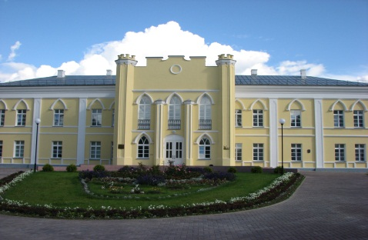There are 85 historical and cultural monuments on the territory of region. Among them are:

***Potyomkin’s palace***

The palace was restored in 2007. It’s become a monument of architecture of Russian classicism.

Now, a registry office and the local history museum are in the building of the palace.

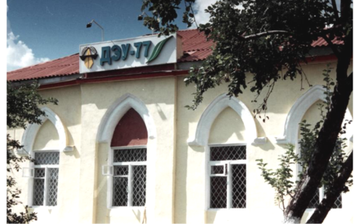

***The post station***

The first post station was opened in Krichev in 1850.

It served the post way Moscow-Brest – Warsaw.

Post station – a monument of neogothic architecture.

**Monasteries and temples**

**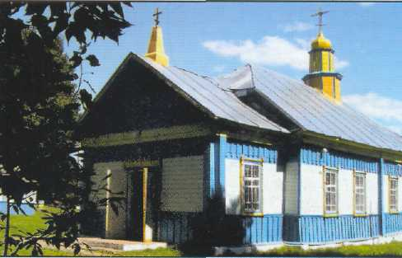*Saint Nikolay church***

It’s the monument of wooden architecture of the end of 19th - the beginning of the 20th centuries . The church was built from wood on Zamkovaya hill. The rectangular shape of a building with a sloping roof was typical for that time. The chapel was attached directly to the main building. Ancient icons haven’t been saved.

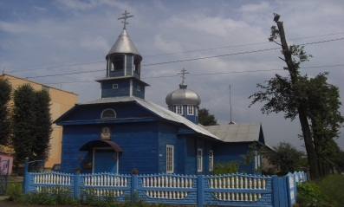

***Temple of the Cover of Blessed Virgin***

It’s the monument of wooden architecture of the end of 19th and the beginning of the20th centuries. The temple was erected in honour of liberation of Krichev from fascist invaders.

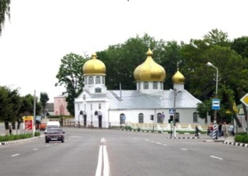***Sacred Voskresensky Paraskevinsky cathedral***

At the end of the 19th century Svyato-Voskresensko-Pyatnitsky temple was erected in center of Krichev. During the Soviet period it didn't serve. Restoration of the temple began in 1991.

***9. Investment potential***

From 2005 till 2011 about 2,7 trillion rubles were invested in the economy of region.

**Investments into the fixed capital of the district in 2005-2011, billion rubles**

There are all conditions for the development of business, investment activity and for opening of new productions in our district. The unique geographical position, proximity to the Russian Federation’s border will allow the created enterprises to get competitive advantage at work in the markets of the countries which will work in united economic space.

Strategic priorities of the area are directed on strengthening of investment climate and increase of competitiveness of the available enterprises.

**Legal regulation of the investment activity**

1. Civil code of the Republic of Belarus.

2. Investment Code of the Republic of Belarus.

3. The code of the Republic of Belarus about the land.

4. The code of the Republic of Belarus about subsoils.

5. The decree of the President of theRepublic of Belarus No. 10 from August 6, 2009. «About the creation of the additional conditions for investment activity in the Republic of Belarus».

6. The decree of the President of the Republic of Belarus No. 6 from May 7, 2012. «About the stimulation of business activity on the territory of medium and small towns and rural areas».

7. The instruction of the President of the Republic of Belarus No. 4 from December 31, 2010 «About the development of an enterprise initiative and stimulation of business activity in the Republic of Belarus».

8. The decree of the President of the Republic of Belarus № 667 from December 27, 2007 "About confiscation and granting the land lots".

9. The decree of the President of the Republic of Belarus No. 450 from September 1, 2010 «About licensing of some kinds of activity».

10. The law of the Republic of Belarus from July 5, 2004. "About architectural, town-planning and construction activity in the Republic of Belarus".

11. The resolution of the Council of ministers of the Republic of Belarus No. 1058 from August 6, 2011 «About arrangements for realization of the Decree of the President of the Republic of Belarus No. 4 from June 6, 201».

**The priority directions of attraction of investments in Krichev region:**

Competitive advantages:

- favorable geographical arrangement: Krichevsky the area is along Granitsa Route P43 of the Russian Federation (Zvenchatk) — Krichev — Bobruisk — Ivatsevichi, the distance to Minsk makes 370 km, to border from the Russian Federation - 39 km, to Moscow - 470 km, there is a large railway junction – station Krichev

- existence of investment platforms

**Organization of the**

**enterprises for**

**rendering of**

**transport and**

**logistic service**

Competitive advantages:

- urgency of the direction of development of renewables

- urgency of the direction of processing of a waste

- existence of investment platforms

**The production organization on development of renewables and on processing of waste**

Competitive advantages:

- existence around one of the largest plants on production of cement of JSC Krichevtsementnoshifer

- existence of investment platforms

- a direction urgency in medium-term and long-term prospects

**Organization of production of construction materials and designs**

Competitive advantages:

- great demand on drinking water

- existence of sources of qualitative drinking water

**Organization of pouring of drinkable and mineral water and soft drinks**

Competitive advantages:

- geographical arrangement: Krichev region is along Granitsa Route P43 of the Russian Federation (Zvenchatk) — Krichev — Bobruisk — Ivatsevichi with the number of 100 lorries in an hour

- demand of road service on car repairs

- demand of road service on accommodation and food

**Roadside service**

**including service of**

**cars**

Competitive advantages:

-There are 85 historical and culture monuments on the territory of Krichev region. Potyomkin's Palace is a restored monument of architecture of XIX century

- a unique natural landscape, fine climate

- existence of investment platforms

**Rendering of tourist services including recreation center**

Competitive advantages:

- a demand of service in the organization of family rest in a hotel entertainment complex with bowling club, hotels are on 50 places, cafe bar is on 50 seats with overland and water recreation areas (expected size of investments about 60 billion rubles (7,5 mln. dollars of the USA or 6 million euros)

**Construction of hotel entertainment complex**

**Building of restaurant (cafe) on 80-100 seats in Krichev**

Competitive advantages:

- service of public catering

- existence of a free market in Krichev

- existence of investment platforms

Competitive advantages:

- prospects of agricultural production development

- existence of investment platforms

**Organization of**

**agricultural**

**production**

**Priority direction:**

**Organization of pouring of drinkable water and soft drinks**

|  |  |
| --- | --- |
| **Investment platform** | |
| Characteristic of a platform | S ≈ 1,0 hectares (of v.Kalinino) |
| Planned buildings and constructions | 1000 m² |
| Engineering and transport infrastructure | - water supply- to the closest point of connection is 100-120 m  - water removal (sewerage) -  - power supply - connection possibility till 30 kW  - gas supply - the closest point of connection is 500 m  - access roads - distance to the highway of republican significance of R 43 - 5,6 km, distance to the unloading and loading station Krichev of-10 km  - installation of telephones - the operator of cellular mobile communication Welkom, MTS, Life, regional telecommunication |
| Possible directions | Organization of drinking and mineral water and soft drinks |

**Priority direction:**

**Organization of production and construction materials and designs**

|  |  |
| --- | --- |
| **Investment platform** | |
| The characteristic of a platform | S= 3,9 hectares ( Krupskaya St.) |
| Planned buildings and constructions | available brick constructions:  ABK building - the square of 555 m ²,  warehouse - the square of 638 m ²,  office building - the square of 415 m ²,  check point checkpoint - the square of 150 m ²,  warehouse - the square of 346,1 m ² |
| Engineering and transport infrastructure | **-** water supply - to the closest point of connection of 80-100 m  - water removal - isn't present  - power supply is available transformer substation in capacity of 200 kW  - gas supply - to the closest point of connection - 70 m,  - access roads - distance to the highway of republican significance of R 43 - 2,5 km, R 15 - 0,7 km; distance to the unloading and loading station Krichev - 3,3 km  - installation of telephones is the operator of cellular mobile communication Welkom, MTS, Life, regional telecommunication |
| Expected directions | creation of productions and construction materials and designs |

|  |  |
| --- | --- |
| **Investment platform** | |
| The characteristic of a platform | S = 1,5 hectares (the region of SU base - 93) |
| Planned buildings and constructions | 1000 m ² |
| Engineering and transport infrastructure | - water supply - to the closest point of connection of 20-50 m  - water removal (sewerage) - 5-15 m  - power supply – is necessary construction of transformer substation  - gas supply - to the closest point of connection of 300 m  - access roads - distance to the highway of republican significance of R 43 - 3,3 km, R 15 - 1,8 km; distance to the unloading and loading station. Krichev - 4,6 km  - installation of telephones is the operator of cellular mobile communication Welkom, MTS, Life |
| Expected directions | creation of productions and construction materials and designs |

|  |  |
| --- | --- |
| **Investment platform** | |
| Characteristic of a platform | S = 3,0 hectares (v. Zalesovichi ) |
| Planned buildings and constructions | there is a construction of repair shops of the square of 931,1 m ² |
| The engineering and transport infrastructure | - water supply - no  - water removal (sewerage) - no  - power supply is available transformer substation in capacity to 500 kW  - gas supply - to the closest point of connection of 1,0 km  - access roads - Krichev Highway - Zalesovichi (KUP "Mogolevobldorstra"), distance to the highway of republican significance of R of 43-5 km, R 15 - 5,5 km; distance to the unloading and loading station Krichev of-5 km  - installation of telephones is the operator of cellular mobile communication Welkom, MTS, Life, regional telecommunication |
| Expected directions | creation of productions and construction materials and designs |

|  |  |
| --- | --- |
| **Investment platform** | |
| Characteristic of a platform | S = 3,0 hectares (Komsomolskaya St.) |
| Planned buildings and constructions | 1000 m² |
| Engineering and transport infrastructure | - water supply - to the closest point of connection of 280-300 m  - water removal (sewerage) of-350-400 m  - power supply - is necessary construction of transformer substation  - gas supply - to the closest point of connection of 400-500 m  - access roads - distance to the highway of republican value of R 43 - 3,1 km, R 15 - 1,7 km distance to the unloading and loading station Krichev - 2,8 km  - installation of telephones - the operator of cellular mobile communication Welkom, MTS, Life, regional telecommunication |
| Expected directions | сreation of productions and construction materials and designs |

|  |  |
| --- | --- |
| **Investment platform** | |
| Characteristic of a platform | S = 5,0 hectares (area Komsomolskaya St.) |
| Planned buildings and constructions | 2000 m² |
| Engineering and transport infrastructure | - water supply - to the closest point of connection of 400-450 m  - water removal (sewerage) - 200-250 m  - power supply - is necessary construction of transformer substation  - gas supply - to the closest point of connection of 150-160 m  - access roads - distance to the highway of republican value of R 43 - 3,6 km, R 15 - 1,2 km distance to the unloading and loading station Krichev - 2,3 km  - installation of telephones - the operator of cellular mobile communication Velkom, MTS, Life, regional telecommunication |
| Expected directions | creation of productions and construction materials and designs |

|  |  |  |  |
| --- | --- | --- | --- |
| **Investment platform** | | | |
| Characteristic of a platform | | S = 2,0 hectares (Shosseynaya St. to Kommunisticheskaya St.) | |
| Planned buildings and constructions | | 1000 m² | |
| Engineering and transport infrastructure | | - water supply - to the closest point of connection of 100-200 m  - water removal (sewerage) - 100-200 m  - power supply - connection possibility to 30 kW  - gas supply – to the closest point of connection of 50-200 m  - access roads – distance to the highway of republican significance of R 43 - 5,5 km, R 15 - 0,3 km; distance to the unloading and loading station Krichev - 1,7 km  - installation of telephones - the operator of cellular mobile communication Velkom, MTS, Life, regional telecommunication | |
| Expected directions | | creation of productions and construction materials and designs | |

|  |  |
| --- | --- |
| **Investment platform** | |
| Characteristic of a platform | S = 2,0 hectares (base suburban) |
| Planned buildings and constructions | 1000 m² |
| Engineering and transport infrastructure | - water supply - to the closest point of connection of 100-150 m  - water removal (sewerage) – 100-150 m  - power supply - connection possibility to 100 kW  - gas supply - to the closest point of connection of 3 km  - access roads - distance to the highway of republican value of R 15 - 0,1 km distance to the unloading and loading Art. Krichev - 3 km  - installation of telephones - the operator of cellular mobile communication Welkom, MTS, Layf, regional telecommunication |
| Expected directions | creation of productions of construction materials and designs |

|  |  |
| --- | --- |
| **Investment platform** | |
| Characteristic of a platform | S = 2,0 hectares (base of agricultural chemistry) |
| Planned buildings and constructions | 1000 m² |
| Engineering and transport infrastructure | - water supply - to the closest point of connection of 70-100 m  - water removal (sewerage) - no  - power supply - connection possibility to 100 kW  - gas supply - to the closest point of connection of 3 km  - access roads - distance to the highway of republican sgnificance of R 15 - 0,1 km distance to the unloading and loading station Krichev - 2,7 km  - installation of telephones is the operator of cellular mobile communication Velkom, MTS, Life, regional telecommunication |
| Expected directions | creation of productions and construction materials and designs |

**Priority direction:**

**Organization of production to develop renewable energy and waste recycling**

|  |  |
| --- | --- |
| Investment area | |
| Area characteristics | S = 5 ha (v. Prygovka) |
| Planned buildings | 2000m² |
| Engineering and transport infrastructure | **-** water supply - no  - wastewater - no  - electricity wiring construction of transformer substations and overhead lines 10 is necessary  - gas – 10 km to the nearest connection point  - [access communications](http://lingvopro.abbyyonline.com/ru/Search/GlossaryItemExtraInfo?text=%d0%bf%d0%be%d0%b4%d1%8a%d0%b5%d0%b7%d0%b4%d0%bd%d1%8b%d0%b5%20%d0%bf%d1%83%d1%82%d0%b8&translation=access%20communications&srcLang=ru&destLang=en&author=Administrator" \o "Показать примеры употребления) - the distance to the road of national importance P 43 is 1.9 km, the distance to the loading station Krichev is 14.5km  - telephone service - cellular mobile communication Velcom, MTS, Life, regional telephone service |
| Prospective directions | The organization of waste recycling |

|  |  |
| --- | --- |
| **Investment area** | |
| Area characteristics | S = 300 ha (v. Dyagovichi) |
| Planned buildings | wind installations, solar panels |
| Engineering and transport infrastructure | **-** water supply - no  - wastewater - no  - electricity - the purchase and installation of transformer substations are required  - gas – 25 km to the nearest connection point  - [access communications](http://lingvopro.abbyyonline.com/ru/Search/GlossaryItemExtraInfo?text=%d0%bf%d0%be%d0%b4%d1%8a%d0%b5%d0%b7%d0%b4%d0%bd%d1%8b%d0%b5%20%d0%bf%d1%83%d1%82%d0%b8&translation=access%20communications&srcLang=ru&destLang=en&author=Administrator" \o "Показать примеры употребления) - the distance to the road of national importance P 43 is 10 km, the distance to the loading station Krichev is 20.3 km  - telephone service - cellular mobile communication Velcom, MTS, Life, regional telephone service |
| Prospective directions | Creation of a wind farm, placing solar panels |

**Priority direction:**

**Organization of enterprises to provide transport and logistics services**

|  |  |
| --- | --- |
| **Investment area** | |
| Area characteristics | S = 5 ha () |
| Planned buildings | 2000m² |
| Engineering and transport infrastructure | **-** water supply - 1000- 1100 m to the nearest connection point  - wastewater - no  - electricity- the ability to connect up to 100 kW  - gas – 3.2 km to the nearest connection point  - [access communications](http://lingvopro.abbyyonline.com/ru/Search/GlossaryItemExtraInfo?text=%d0%bf%d0%be%d0%b4%d1%8a%d0%b5%d0%b7%d0%b4%d0%bd%d1%8b%d0%b5%20%d0%bf%d1%83%d1%82%d0%b8&translation=access%20communications&srcLang=ru&destLang=en&author=Administrator" \o "Показать примеры употребления) - the distance to the road of national importance P 15 is 0.2 km, the distance to the loading station Krichev is 2.7 km  - telephone service - cellular mobile communication Velcom, MTS, Life, regional telephone service |
| Prospective directions | logistics centre |

**Priority direction:**

**Provision of roadside services, including automobile service**

|  |  |
| --- | --- |
| Investment area | |
| Area characteristics | S =0. 5 ha (v.Krasnaya Buda - in a distance of 0.1 km from the highway P43) |
| Planned buildings | 200m² |
| Engineering and transport infrastructure | **-** water supply -30-40 m to the nearest connection point  - wastewater – 50-100 m  - electricity- the ability to connect up to 300 kW  - gas- 13.0 km to the nearest connection point  - [access communications](http://lingvopro.abbyyonline.com/ru/Search/GlossaryItemExtraInfo?text=%d0%bf%d0%be%d0%b4%d1%8a%d0%b5%d0%b7%d0%b4%d0%bd%d1%8b%d0%b5%20%d0%bf%d1%83%d1%82%d0%b8&translation=access%20communications&srcLang=ru&destLang=en&author=Administrator" \o "Показать примеры употребления) - the distance to the road of national importance P 43 is 0.1 km, the distance to the loading station Krichev is 12 km  - telephone service - cellular mobile communication Velcom, MTS, Life, regional telephone service |
| Priority directions | Provide roadside services , including automobile service |

**Priority direction:**

**Provision of travel services, including the construction of the recreation center**

|  |  |
| --- | --- |
| **Investment area** | |
| Area characteristics | S = 2.0 ha (v. Ivanovka) |
| Planned buildings | 400m², located near forest area |
| Engineering and transport infrastructure | **-** water supply – 50-60 m to the nearest connection point  - wastewater - no  - electricity- the ability to connect up to 50 kW  - gas – 500 m to the nearest connection point  - [access communications](http://lingvopro.abbyyonline.com/ru/Search/GlossaryItemExtraInfo?text=%d0%bf%d0%be%d0%b4%d1%8a%d0%b5%d0%b7%d0%b4%d0%bd%d1%8b%d0%b5%20%d0%bf%d1%83%d1%82%d0%b8&translation=access%20communications&srcLang=ru&destLang=en&author=Administrator" \o "Показать примеры употребления) - highway - Krichev-Hodosy, the distance to the road of national importance P 43 - 9 km, P 15 - 3.5 km, the distance to the loading and unloading station. Krichev - 4.5 km  - telephone service - cellular mobile communication Velcom, MTS, Life, regional telephone service |
| Prospective directions | Providing of travel services, construction of the recreation centre |

|  |  |
| --- | --- |
| **Investment area** | |
| Area characteristics | S = 2.0 ha (v. Luty) |
| Planned buildings | 500m², located near forest area |
| Engineering and transport infrastructure | **-** water supply - no  - wastewater - no  - electricity- the ability to connect up to 30 kW  - gas – 15-16 km to the nearest connection point  - [access communications](http://lingvopro.abbyyonline.com/ru/Search/GlossaryItemExtraInfo?text=%d0%bf%d0%be%d0%b4%d1%8a%d0%b5%d0%b7%d0%b4%d0%bd%d1%8b%d0%b5%20%d0%bf%d1%83%d1%82%d0%b8&translation=access%20communications&srcLang=ru&destLang=en&author=Administrator" \o "Показать примеры употребления) - the distance to the road of national importance P 43 is 22 km, the distance to the loading station Krichev is 17km  - telephone service - cellular mobile communication Velcom, MTS, Life, regional telephone service |
| Supposed directions | Providing of travel services, construction of the recreation centre |

|  |  |
| --- | --- |
| **Investment area** | |
| Area characteristics | S = 5 ha (v. Zarubets) |
| Planned buildings | 500m² |
| Engineering and transport infrastructure | **-** water supply - no  - wastewater - no  - electricity- construction of transformer substations and overhead lines is necessary  - gas – 18 km to the nearest connection point  - [access communications](http://lingvopro.abbyyonline.com/ru/Search/GlossaryItemExtraInfo?text=%d0%bf%d0%be%d0%b4%d1%8a%d0%b5%d0%b7%d0%b4%d0%bd%d1%8b%d0%b5%20%d0%bf%d1%83%d1%82%d0%b8&translation=access%20communications&srcLang=ru&destLang=en&author=Administrator" \o "Показать примеры употребления) – highway Krasnaya Buda- Dyagovichi- Zarubets, the distance to the road of national importance P 43 is 15 km, the distance to the loading station Krichev is 27km  - telephone service - cellular mobile communication Velcom, MTS, Life, regional telephone service |
| Prospective directions | Providing of tourist services, construction of the recreation centre |

|  |  |
| --- | --- |
| **Investment area** | |
| Area characteristics | S = 2.0 ha (v. Nanoskovo) |
| Planned buildings | 500m² |
| Engineering and transport infrastructure | **-** water supply - no  - wastewater - no  - electricity- the ability to connect up to 30 kW  - gas – 33-34 km to the nearest connection point  - [access communications](http://lingvopro.abbyyonline.com/ru/Search/GlossaryItemExtraInfo?text=%d0%bf%d0%be%d0%b4%d1%8a%d0%b5%d0%b7%d0%b4%d0%bd%d1%8b%d0%b5%20%d0%bf%d1%83%d1%82%d0%b8&translation=access%20communications&srcLang=ru&destLang=en&author=Administrator" \o "Показать примеры употребления) - the distance to the road of national importance P 43 is 13 km, the distance to the loading station Krichev is 23.3 km  - telephone service - cellular mobile communication Velcom, MTS, Life |
| Supposed directions | Providing of travel services, construction of the recreation centre |

**Priority direction:**

**Construction of the hotel entertainment complex**

|  |  |  |
| --- | --- | --- |
| **Investment area** | | |
| Area characteristics | S = 2.5 ha (v. Prudok) |
| Planned buildings | 1000m² |
| Engineering and transport infrastructure | **-** water supply - no  - wastewater - no  - electricity-construction of transformer substations and overhead lines is necessary  - gas – 3 km to the nearest connection point  - [access communications](http://lingvopro.abbyyonline.com/ru/Search/GlossaryItemExtraInfo?text=%d0%bf%d0%be%d0%b4%d1%8a%d0%b5%d0%b7%d0%b4%d0%bd%d1%8b%d0%b5%20%d0%bf%d1%83%d1%82%d0%b8&translation=access%20communications&srcLang=ru&destLang=en&author=Administrator" \o "Показать примеры употребления) - the distance to the road of national importance P 43 is 3 km, the distance to the loading station Krichev is 9 km  - telephone service - cellular mobile communication Velcom, MTS, Life, regional telephone service |
| Prospective directions | Construction of the hotel entertainment complex |

**Priority direction:**

**Construction of a restaurant (cafe) for 80-100 seats in the town of Krichev**

|  |  |
| --- | --- |
| **Investment area** | |
| Area characteristics | S = 0.06 ha (Parkovaya St. – Oktyabrskaya St.) |
| Planned buildings | 250m² |
| Engineering and transport infrastructure | **-** water supply – 80- 120 m to the nearest connection point  - wastewater – 100-200 m  - electricity- the ability to connect up to 10 kW  - gas – 50-70 m to the nearest connection point  - [access communications](http://lingvopro.abbyyonline.com/ru/Search/GlossaryItemExtraInfo?text=%d0%bf%d0%be%d0%b4%d1%8a%d0%b5%d0%b7%d0%b4%d0%bd%d1%8b%d0%b5%20%d0%bf%d1%83%d1%82%d0%b8&translation=access%20communications&srcLang=ru&destLang=en&author=Administrator" \o "Показать примеры употребления) - the distance to the road of national importance P 43 is 1.2 km, the distance to the loading station Krichev is 3.7 km  - telephone service - cellular mobile communication Velcom, MTS, Life, regional telephone service |
| Prospective directions | Construction of a restaurant (cafe) for 80-100 seats in the town of Krichev |

**Priority direction:**

**Organisation of agricultural production**

|  |  |
| --- | --- |
| **Investment area** | |
| Area characteristics | S = 400 ha (v. Dyagovichi) |
| Planned buildings | 3000m² |
| Engineering and transport infrastructure | **-** water supply – 50-60 m to the nearest connection point  - wastewater – 50-100 m  - electricity- the ability to connect up to 100 kW  - gas – 22 km to the nearest connection point  - [access communications](http://lingvopro.abbyyonline.com/ru/Search/GlossaryItemExtraInfo?text=%d0%bf%d0%be%d0%b4%d1%8a%d0%b5%d0%b7%d0%b4%d0%bd%d1%8b%d0%b5%20%d0%bf%d1%83%d1%82%d0%b8&translation=access%20communications&srcLang=ru&destLang=en&author=Administrator" \o "Показать примеры употребления) – highway Krasnaya Buda- Dyagovichi- Zarubets, the distance to the road of national importance P 43 is 10.5 km, the distance to the loading station Krichev is 22.5km  - telephone service - cellular mobile communication Velcom, MTS, Life, regional telephone service |
| Prospective directions | The organization of agricultural production |

**Scheme for the implementation of the investment project**

Preliminary approval of the location of the land for the construction of the object with Krichev executive committee

Into possession

To rent

Permission to design and exploration work

Development of a construction project

Permission to accomplish of the construction works

Development of the project of land allocation

Making the decision on withdrawal and granting of a land plot

Setting boundaries for a land plot in the field

Payments for land

Lease contract

State registration of a land plot creation and arising of the right to it

The project construction

PROJECT

**INVESTMENT AGREEMENT**

between Belarus and _________________________________________________ (full name of the legal entity (representation)

____________________________________________________________________,

or surname, name, patronymic of the individual entrepreneur (foreign individual),

on the implementation of the investment project «____________________________

(name of

_______________________________________________________________»

investment project)

|  |  |  |
| --- | --- | --- |
| __ _________ 2014 | № _____ | Mogilev,  The Republic of Belarus |

The Republic of Belarus represented by Mogilev Regional Executive Committee, which acts on behalf of the Chairman of the Mogilev Regional Executive Committee Pyotr Rudnik, acting on the basis of the Law of January 4, 2010, "On Local Government and Self-Government in the Republic of Belarus", hereinafter referred to as "The Republic of Belarus " on the one hand, and ______________________________________________

(full name of the legal entity (office)

___________________________________________________________________,

surname, name, patronymic of the individual entrepreneur (foreign individual),

(registered) ________________________________________________,

(Name of the state agency that registered business entity (the date and number of the decision on registration)

in the Unified State Register of Legal Entities and Individual Entrepreneurs number ___________________), represented by ___________

(number of the registration)

____________________________________________________________________,

(post, surname, name, patronymic individual)

acting under _______________________________________

(Normative legal act, statute, regulation or other

____________________________________________________________________,

proof of authority)

called as the "Investor" on the other hand, together called the Parties, guided by the Investment Code of the Republic of Belarus, the Decree of the President dated August 6, 2009 № 10 "On creation of additional conditions for investment activity in the Republic of Belarus", the Resolution Council of Ministers on August 6, 2011 № 1058 "On measures to implement the Presidential Decree of June 6, 2011 № 4", expressing their mutual interest in establishing the conditions for cooperation in the successful implementation of the investment project «______________________________________________________»,

(name of the investment project)

based on the decision of the Mogilev Region ___ __________ 2014 № _______ «On conclusion of an investment agreement between Belarus and ______________________________________________________________»,

(full name of the legal entity (office) or surname, name, patronymic of the individual entrepreneur (foreign individual)

concluded the investment agreement (hereinafter - Agreement) as follows:

DEFINITIONS

1. For the purposes of the contract, the following terms and their definitions are used:

«"Investment" - property, including cash resources, investor-owned property right or other proprietary right and the rights of property, invested by the investor in the investment object in order to implement the investment project;

«Investment activity» – actions of the investor to invest in the implementation of the project;

«Investment project» –__________________________________;

(name of the investment project)

«Investor» – ______________________________________________ .

(full name of the legal entity (office) or surname, name, patronymic of the individual entrepreneur (foreign individual)

SUBJECT OF THE CONTRACT

2. The subject of the contract is the investment activities conducted by the investor in the Republic of Belarus to implement the investment project.

3 The object of investing is _______________________________________________________________,

(name of the investment project)

which involves _______________________________________________________________

(construction, organization, or the expansion of the object of investments, etc.).)

4. The volume of investments is ________________________________

(amount in figures and words)

Belarusian roubles with term investments during the realization of the project.

5. The term of the investment project is ___________________ month from the date of entry into force of the agreement, including (term in numbers and words)

the following steps:

the first step is the design and installation of a zero cycle. The period of the step is no more than ___ months from the date of entry into force of the agreement;

the second step is the construction and commissioning of the facility. The period of the phase is no more than ___ months from the date of entry into force of the agreement.

(Note: More steps may be possible depending on the specifics of the investment activities)

RIGHTS AND OBLIGATIONS OF THE PARTIES

6. The investor is obliged to:

6.1. ensure the realization of the investment project in amounts determined by paragraph 4 of the agreement and in the terms defined by paragraph 5 of the agreement;

6.2. create at least ___ jobs;

6.3. ensure compliance with the investment, financial, tax, labor, the environment protection and other legislation;

6.4.  reimburse the costs connected with the benefits and preferences according to the Decree of the President of the Republic of Belarus dated August 6, 2009 № 10 "On creation of additional conditions for investment activity in the Republic of Belarus" (hereinafter - the Decree) and the agreement in case of non-observance or improper observance of its obligations set out in paragraphs 6.1, 6.2 and 6.3 of this agreement, unless the law or the contract does not provide other liability or other consequences of the violation;

6.5. apply to ____________________________________________

(name of the executive committee that provides the plot of land for the project)

with an application for the design and approval of the placement choice of the claimed plot after the conclusion and registration in the prescribed manner of the agreement;

6.6. quarterly basis by the 10th of the month following the quarter, submit to the Mogilev Regional Executive Committee information about the course of implementation of the investment project and the conditions of the contract.

7. The  Investor after the agreement in the course of the realization of the investment project has the right to:

7.1. construct objects stipulated by the investment project simultaneously with the development, expert examination, and approval in the established order of the design and estimate documentation for each of the stages of construction with simultaneous designing of subsequent stages of the said construction. In case of using design documentation, prepared according to foreign norms and standards in the field of construction which are put into force on the territory of the Republic of Belarus, there should be done linkage of objects to their placement subject to technical specifications for engineering facilities and to the results of geological and geodesic exploration. In other cases of using design documentation which is prepared abroad, there should be done its adjustment in order to correspond legislative acts and technical standards of the Republic of Belarus;

7.2. be allotted, on the right of lease, without holding an auction, a land plot of the required size for the construction of objects stipulated by the investment projects (hereinafter – the land plot), with formalization of necessary documents for the allocation of the land plot simultaneously with construction works. At the same time, before state registration in established order of the objects created within investment project and emerging of corresponding rights, the investor does not have the right to settle bargains with these objects and/or with land plot which lead or provide for lapse of right to other persons;

7.3. construct objects, stipulated by investment project, with the right to remove objects of flora without compensating the cost of the objects being removed. Wood received is sold in established order;

7.4. for deduction of value added tax (with exception of the sums which are not subject to such deduction according to legislation) paid on goods (services), acquired (imported on the territory of the Republic of Belarus) property rights, used for designing and constructing (reconstructing), fitting the objects, stipulated by investment agreement, despite the amount of value added taxes calculated on selling of goods and services or property rights. The grounds for such tax deduction is a list of goods/services, property rights acquired (imported on the territory of the Republic of Belarus)agreed with Mogilev Regional Executive Committee and used for designing and constructing (reconstructing), fitting the objects, stipulated by investment agreement, with indicating such amounts of value added tax, submitted by the investor and/or the organization created in the established order by that investor or with its participation to taxing authorities.

7.5. select without holding tenders general developer, general and subcontractors for designing, constructing and other activities for construction of the objects, stipulated by investment agreement, as well as for their renovation, reconstruction, restoration, and equipping with services and utilities;

8. After making the agreement during the implementation of the investment project the investor is released from:

8.1. the payment to the republic budget for the right to conclude the contract on land plot lease;

8.2. land tax or rent for land plots owned by the State, provided for building of the objects under investment agreement for the period of designing and building of these objects till 31st December of the year following the year in which the construction was finished;

8.3. to be released from compensation of losses of agricultural and/or forestry production, caused by the seizure of lands for implementation of the investment project;

8.4. payment of import customs duties (in the light of international obligations of the Republic of Belarus) and value added tax, imposed by customs authorities when importing to the territory of the Republic of Belarus technological equipment (components and spare parts to it) with aim of using it on the territory of the Republic of Belarus for the implementation of the investment project. The confirming document is a list of goods imported by the investor and/or the organization in the established order created by that investor or with its participation for implementation of the investment project. This list is to be agreed with Mogilev Regional Executive Committee in established order. In the case of improper use of the goods imported with such a benefit, the customs duties and value added tax are to be recovered in accordance with the legislation;

8.5. payment of the state duty for the issue of permits to employ in the Republic of Belarus foreign labor force, special permits to be engaged in labor activity in the Republic of Belarus, and foreign citizens and stateless persons which are employed by investor or and/or an organization in established order set up in the Republic of Belarus by investor or with his participation for the implementation of investment project, - for the issue of permit of temporary stay in the Republic of Belarus. The term of making the decision on the issue (dismissal) of special permits to be engaged in labor activity in the Republic of Belarus to foreign citizens and stateless persons which are employed by investor for implementation of the investment project can’t be more than 7 days and the period of giving the conclusion on possibility (impossibility) of engaging a foreign citizen or a stateless person is 2 working days.

9. The Republic of Belarus is obliged:

9.1. to grant to the investor all the preferences according to legislative acts of the Republic of Belarus and the present agreement;

9.2. to ensure stability of the rights of the Investor and protection of the investments according to the present agreement and legislative acts of the Republic of Belarus;

10. The Republic of Belarus has the right:

10.1. to cancel unilaterally its obligations under the present investment agreement in case of material violation by the Investor of his obligations;

10.2. to be compensated by the Investor in case of non-observance or improper observance of his obligations under the present agreement the amounts of preferences provided to the Investor according to subparagraphs 6.1, 6.2 and 6.3 of paragraph 6 of the present agreement, if another responsibility or other consequences are not provided by legislation or the present agreement.

THE REQUIREMENTS OF INFORMATION CONFIDENTIALITY AND RESPONSIBILITIES OF THE PARTIES

11. The parties are obliged:

11.1. not to spread information to third person, connected with making and executing of the agreement, with the exception of information given in proper order to government bodies of the Republic of Belarus;

11.2. to compensate according to the legislation the real damage suffered by the other party in case of non-observance or improper observance by the guilty party its obligations under the present agreement.

12. neither party is responsible for full or partial non-fulfillment of its obligations if such non-fulfillment was due to force-majeure circumstances, such as floods, fires, earthquakes other natural disasters, military operations, acts of terrorism and industrial actions which arouse after the present agreement had been concluded and influenced the improper fulfillment of the present agreement.

PROCEDURE AND PLACE OF JURISDICTION CONNECTED WITH THE AGREEMENT

13. If differences or disputes arise out of the present agreement the Parties will make efforts to settle them amicably by way of holding negotiations, respecting mutual interests. Pretrial procedure of settling disputes is considered obligatory. Written claim is to be treated in the course of 30 calendar days from the date of receipt.

14. All disputes, differences and claims arising out of the present agreement are to be treated according to legislation of the Republic of Belarus in Minsk International Court of Arbitration with Belarusian Chamber of Commerce and Industry, and according to its time-limit.

APPLICABLE RIGHT

15. The law applicable to the present agreement is the law of the Republic of Belarus.

On all issues not covered by the present agreement the Parties are to be guided by the legislation of the Republic of Belarus.

TERM OF VALIDITY

16. The present agreement enters into force from the day of its state registration in the State Register of Investment agreements with the Republic of Belarus and is valid till complete fulfillment of the obligations by the Parties.

17. The present agreement can be terminated in the following cases:

-fulfillment by the Investor of its obligations under the present agreement;

-completion of the term of the present agreement ;

-liquidation of the Investor;

-by agreement of the Parties;

-through the realization by the Republic of Belarus its right to unilateral termination of the agreement in case of non-observance or improper observance of its obligations.

FINAL PROVISIONS

18. The present agreement is drawn up in 2 (two) original copies in the Russian and English languages, one copy for each party. All the copies are identical and have equal legal force.

19. The agreement details alterations and its termination by agreement of the Parties are realized in the established order.

CONTACT DETAILS AND SIGNATURES

|  |  |  |
| --- | --- | --- |
| For the Republic of Belarus |  | The Investor |
| Mogilev City Executive Committee  the Republic of Belarus,  Mogilev, Pervomayskaya St, 71,  current account 3604005060752  the branch № 700 –  Mogilev Regional  Administration JSC JSSB «Belarusbank», code  153801536, UNP 700123853 |  | ООО «ХХХ»  the Republic of Belarus,  city (town). , street, house, flat  c/a…..  UNP  _______ |
| Chairman  _______________P.М.Rudnik |  | Manager  _________________(Name,Surname) |