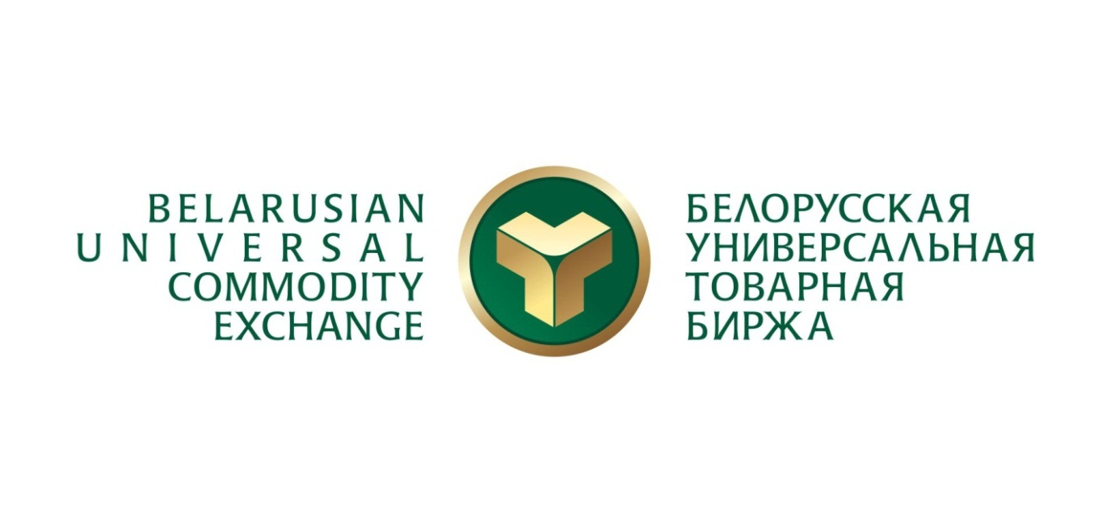

**Belarusian Universal Commodity Exchange**

**Belarusian Universal Commodity Exchange (BUCE)** is the only mercantile exchange in the Republic of Belarus and one of the largest spot exchanges of Eastern Europe. Founded in 2004, BUCE is a crucial economic institution ensuring implementation of market pricing principles and equal access to commodities for all market participants. Besides fostering a healthy competitive environment and setting a fair price range, the Exchange also contributes to the development of an organized wholesale market, facilitates movement of goods from manufacturers to customers and increases the overall transparency of wholesale trade.

Over 3000 commodity items are listed at the Exchange. All of them are subdivided into the following major categories:

1. [**Metal products**](http://butb.by/engl/?page=18): ferrous and non-ferrous metals and articles thereof, scrap and waste of ferrous and non-ferrous metals, cabling and wires, coke, and coal.
2. [**Timber products**](http://butb.by/engl/?page=18): round wood, sawn timber, wood boards, plywood, paper, cardboard, wood chips, fuel briquettes and pellets, timber harvesting services.
3. [**Agricultural products**](http://butb.by/engl/?page=20): milk and whey powder, industrial casein, dairy butter, cottage cheese, rennet cheeses, meat, flour, rawhides, oilcakes, vegetable oils and seeds.
4. [**Industrial and consumer goods**](http://butb.by/engl/?page=21): a wide range of commodities – from advanced industrial machinery and vehicles to construction materials and food.

At present, [industrial and consumer goods (ICG)](https://ts.butb.by/ppt/en)trading is one of BUCE’s priority areas that offers Belarusian and foreign companies a state-of-the-art and highly efficient tool for doing business.

**Key advantages of ICG platform:**

* almost unlimited range of tradable commodities;
* trading online 24/7;
* free pricing based on supply and demand;
* thousands of buyers and seller from 57 countries gathered in one place;
* exchange transactions execution control;
* zero advertising and marketing costs.

One of the main features that makes ICG platform stand out among other international trading platforms is that only accredited companies with unblemished reputation and credit rating are allowed to participate in exchange auctions. Moreover, the entire trading process is strictly monitored by the Exchange so that all contractual obligations were fulfilled.

Thanks to electronic document interchange, one can trade at ICG platform from any part of the world, while the multilingual interface of the trading system allows placing bids and offers in English and Russian languages.

Apart from the price, the participants of exchange auctions can also negotiate quantity, terms of payment and delivery period.

One can participate in trades either on one’s own having passed the accreditation and received an [electronic digital signature (EDS)](http://engl.ecp.by/), or through an [exchange](http://bzk.by/) broker. In the latter case no EDS is required.

All participants of exchange auctions are also able to use BUCE’s subaccount for settlements under exchange transactions. This instrument is similar to a letter of credit with the only difference that unlike a bank BUCE does not take any payment for this service. The use of the subaccount enables the seller to claim payment for the shipped goods only after the buyer confirms their acceptance. This way all non-payment and non-delivery risks are reduced to the minimum.

Goods purchased at the Exchange are delivered by means of the [exchange logistics](http://butb.by/?page=42) mechanism that comprises three elements: **exchange warehouses, exchange carriers** and **exchange experts**.

**Exchange warehouses** registered abroad bring the goods as close to the buyer as possible allowing to collect them on DAP terms from an exchange warehouse located in the country of destination.

Exchange carriers (leading Belarusian and foreign shipping companies cooperating with BUCE) are responsible for delivering purchased goods to exchange warehouses and other locations convenient for the buyer.

The quality of delivered products is ensured by yet another element of the exchange logistics mechanism – **exchange experts**.

BUCE has branches in all regional centers of Belarus as well as offices in Russia, Lithuania, Latvia, Czech Republic, Sweden and Turkey that actively promote the Belarusian products in foreign markets.

BUCE is one of the operators of electronic trading platforms for [government](http://zakupki.butb.by/auctions/index.html) procurements and quotation request procedures. Foreign companies that have obtained an electronic digital signature at [BUCE Certifying Authority](http://ecp.by/index.php?page=293) can participate in government procurements on the same terms as Belarusian economic agents.

Besides organizing and holding exchange auctions, BUCE also provides its clients with a whole package of related services. Among the most popular of them are [information and analysis services](http://butb.by/engl/?page=70). All subscribers gain access to the most up-to-date and accurate information on the commodity exchange market of the Republic of Belarus. Unique data offered by the Exchange serve as a basis for making key managerial decisions and present market participants with an extra competitive advantage.

**Use** [**this link**](http://www.butb.by/?page=356) **to view or download the most recent presentation materials.**

**Contacts**

**Republic of Belarus, 220099, Minsk, Kazintsa 2-200**

**Metal Products**

(+375 17) 309-37-31, [e.bureiko@butb.by](mailto:e.bureiko@butb.by)

**Timber Products**

(+375 17) 309-32-44, [e.malyshev@butb.by](mailto:e.malyshev@butb.by)

**Agricultural Products**

(+375 17) 309-32-01, [v.dereshov@butb.by](mailto:v.dereshov@butb.by)

**Industrial and Consumer Goods**

(+375 17) 309-32-32, [e.miklashevich@butb.by](mailto:e.miklashevich@butb.by)

**Foreign Relations**

(+375 17) 309-32-88, [a.bashliy@butb.by](mailto:a.bashliy@butb.by)

**Government Procurements**

(+375 17) 309-37-45, [zakupki@butb.by](mailto:zakupki@butb.by)

**Information services**

(+375 17) 309-32-90, o.[voytehovich@butb.by](mailto:voytehovich@butb.by)

**WWW.BUTB.BY**