Krynitsa-1"
Light beer.
Highly attenuated beer with clear malty flavour and pronounced hop bitterness.
Density 11.0%
Alcohol 4.0%
Packaging:
proprietary glass bottle 0.5 l,
proprietary PET-bottle 1.0 l, 1.5 l, 2.0 l.

2008—2009 OJSC Krinitsa
krinitsa_market@mail.ru
220070, Minsk, Radialnaya st. 52
Tel: 375 (17) 299-22-22 (reception)
Fax: 375 (17) 299-22-11

Krynitsa Klasichnaye"
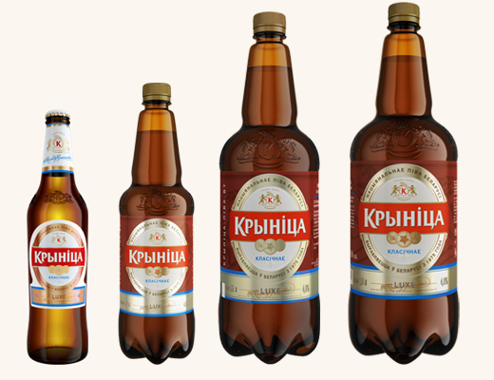
Classic light beer.
Has clear malty flavour with slight hop bitterness and hop aroma.
It is a beverage for real delight.
Density 12.0%
Alcohol 4.6%
Packaging:
aluminum can 0.5 l,
proprietary glass bottle 0.5 l,
proprietary PET-bottle 1.0 l, 1.5 l.

"Krynitsa Ekspartnaye"
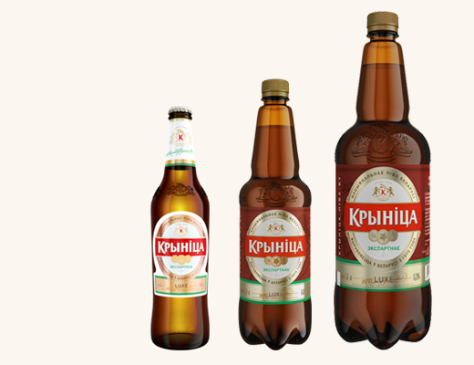
Light beer.
Has clear malty flavour with slight hop bitterness. Brewed thoroughly.
Density 13.0%
Alcohol 5.3%
Packaging:
aluminum can 0.5 l,
proprietary glass bottle 0.5 l,
proprietary PET-bottle 1.0 , 1.5 , 2.0 l.

"Aleksandrya"
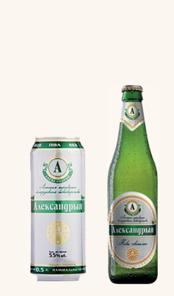
Light dense beer.
Its unique flavour and aroma leave lasting impression on everyone, who tasted this beer.
Density 13.0%
Alcohol 5.5%
Packaging:
aluminum can 0.5 l,
proprietary glass bottle 0.5 l,
proprietary PET-bottle 1.0 l, 1.5 l, 2.0l

